Name:______________ Spanking Shakespeare Essay
Now that we have finished reading Spanking Shakespeare, your task is to write a series of paragraphs about the lessons that can be learned from Shakespeare Shapiro’s life. Shakespeare’s senior year of high school teaches readers:
- it is worthwhile to take risks
- life is full of humour
- writing can be a wonderful thing to do
- friends are really important
- don’t judge a book by its cover
Write an introductory paragraph about how the book appeals to readers through its style and content.
Then choose three of the topics listed above (or any other that you prefer) and create 3 body paragraphs. Use examples from the book (you may use quotes or paraphrase) and include the page number in brackets. Each body paragraph should provide at least 2 specific examples, which means that the essay should have at least 6 examples in total.
In your final body paragraph include the reasons that readers will enjoy Spanking Shakespeare and who you recommend to read it.
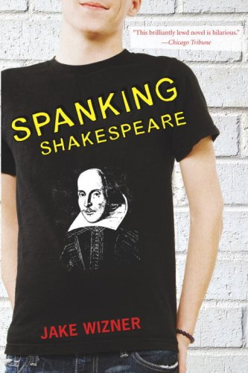

Grade 11 College Essay Rubric

Knowledge/Understanding /10 marks
Displays knowledge of book, evenly distributes information from narrative, thesis is clear and argued throughout, and the purpose of the essay is proven.

Thinking/Inquiry /10 marks
Essay uses direct quotations and/or paraphrasing to efficiently back up information, lead and conclusion are both creative, the ideas within the essay are original and unique, essay is a cohesive body or work (ideas run smoothly into the next), overall effort is obvious through the detail and language that is used to convey the ideas that support a thesis, creative title included.

Communication /10 marks
Proper thesis statement, proper topic sentences, paragraphs are linked throughout, paragraphs are organized, lead provides specific support, conclusion provides specific support, words and sentences are properly composed; formal diction and present tense are used throughout. Proper grammar and spelling throughout.

TOTAL /30 (Writing Curriculum Strand, in addition the marks for Knowledge/Understanding and Thinking/Inquiry will be included in the Literature Studies and Reading Strand)

